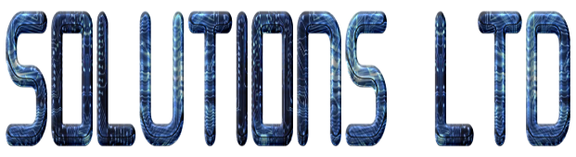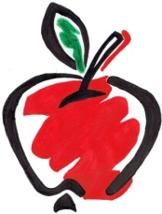

# MODERN SLAVERY AND HUMAN TRAFFICKING POLICY

Apple Technical Solutions Ltd is committed to exiling all acts of modern day slavery and human trafficking within its business and that from within its supply chains, including partners and sub-contractors.

Regarding the Modern Slavery Act 2015 Apple Technical Solutions acknowledges responsibility to ensure that this Act is upheld not only within the organisation but with suppliers of goods and services also.

As part of the companies consideration processes into slavery and human trafficking the supplier approval process will include a survey on control measures undertaken by the supplier. Goods that are imported from sources outside the UK and EU are at a substantial higher risk of slavery/human trafficking problems. These companies will be continually monitored to ensure their level of control of these issues.

Apple Technical Solutions will not deal with any companies knowingly involved in slavery or human trafficking.

Directors of the Apple Technical Solutions will ensure that this policy statement is upheld within the company, and that its objectives are ensured with adequate resources and investing to ensure that slavery and human trafficking does not take part with this organisation and within any of its supply chain.

This policy takes in to account, and supports, the policies, procedures and requirements documented in our integrated management system, compliant with the requirements of ISO 9001:2008, ISO 14001:2004 and OHSAS 18001:2007. This management system identifies our commitment to this policy. Formal procedures concerning Slavery and Human Trafficking have been established, including disciplinary actions where they are breached.

A full copy of this policy and the Modern Slavery Act 2015 will be accessible to all employees and can be found within the HR department upon request.

This policy statement will be reviewed annually and published.

Signed

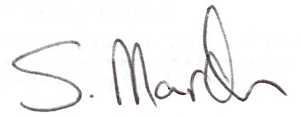

02/08/2016